Aims

One of the aims of this project is to have a working and functioning app for the android IOS. The reason for this is to make the booking system we created to be portable for students and lecturers so if any items need to be borrowed or returned on a whim it can be done without trying to find a computer

The app

This all started for me when I took up the task to try and learn and research Android Studio during one of the sprints close to the Christmas holiday it was around week 9 or 10. How I did this research was by reading two books “Learn Android Studio by Adam Gerber and Clifton Craig” and “Beginning Android Programming by Kevin Grant and Chris Haseman”, I also downloaded Android studio to work though the examples that are in the book. This took me the whole sprint to read two books as I had other work to do at the time as well.

Once the books where done I then had to take a crash course within Java as that was not my strongest so I just went back though what I learned though the last two years. Once all this was done I started the app, at first I was making a standalone app with its own login system and features. But what happened instead was in week 12 it got scrapped and I was told just to mirror the website.

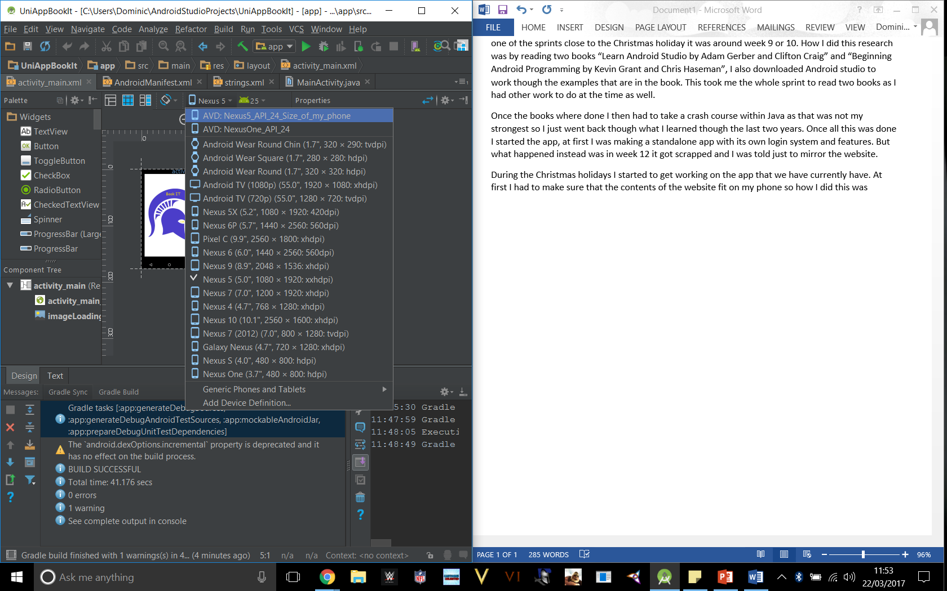During the Christmas holidays I started to get working on the app that we have currently have. At first I had to make sure that the contents of the website fit on my phone so how I did this was I found the dimensions of my phone then I picked the size closes to my phone (Image 1) this did not matter on the tablet as it looks the same on PC.

This is the size of my phone

“Nexus 5”

137.84 mm (5.427 in) H

69.17 mm (2.723 in) W

8.59 mm (0.338 in) D

Image 1

Once this was all of the way I started on the coding the first page I created was the “MainActivity.Java page. On this page you will find code that creates the webpage that opens to the webpage that was created. As you can see this in (image 2) you have the loadUrl function this is the line accesses the raptor folder where are public html folder is. Also on this page it loads a splash screen so I know that the app loads and then loads the webpage.

Image 2

This is the html link to access are website

http://raptor.kent.ac.uk/proj/co600/project/m04_bookit

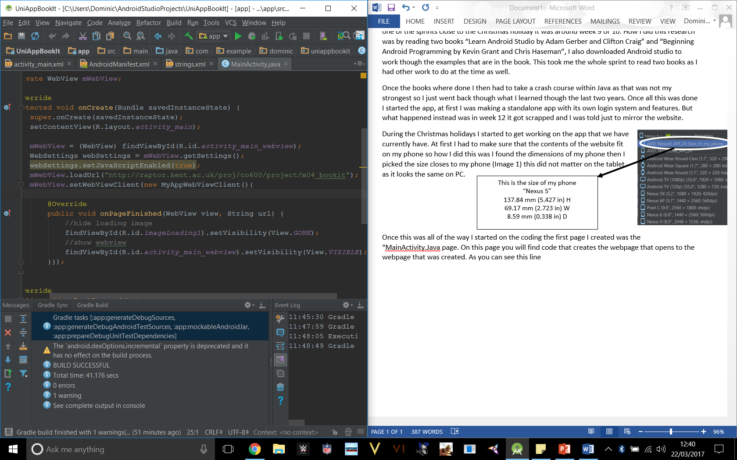

Now on too the the AndroidManifest page. Every application that you create must have an AndroidManifest.xml file (image 3) in its root directory. The manifest file provides essential information about your app to the Android system, which the system must have before it can run any of the app's code.

Image 3

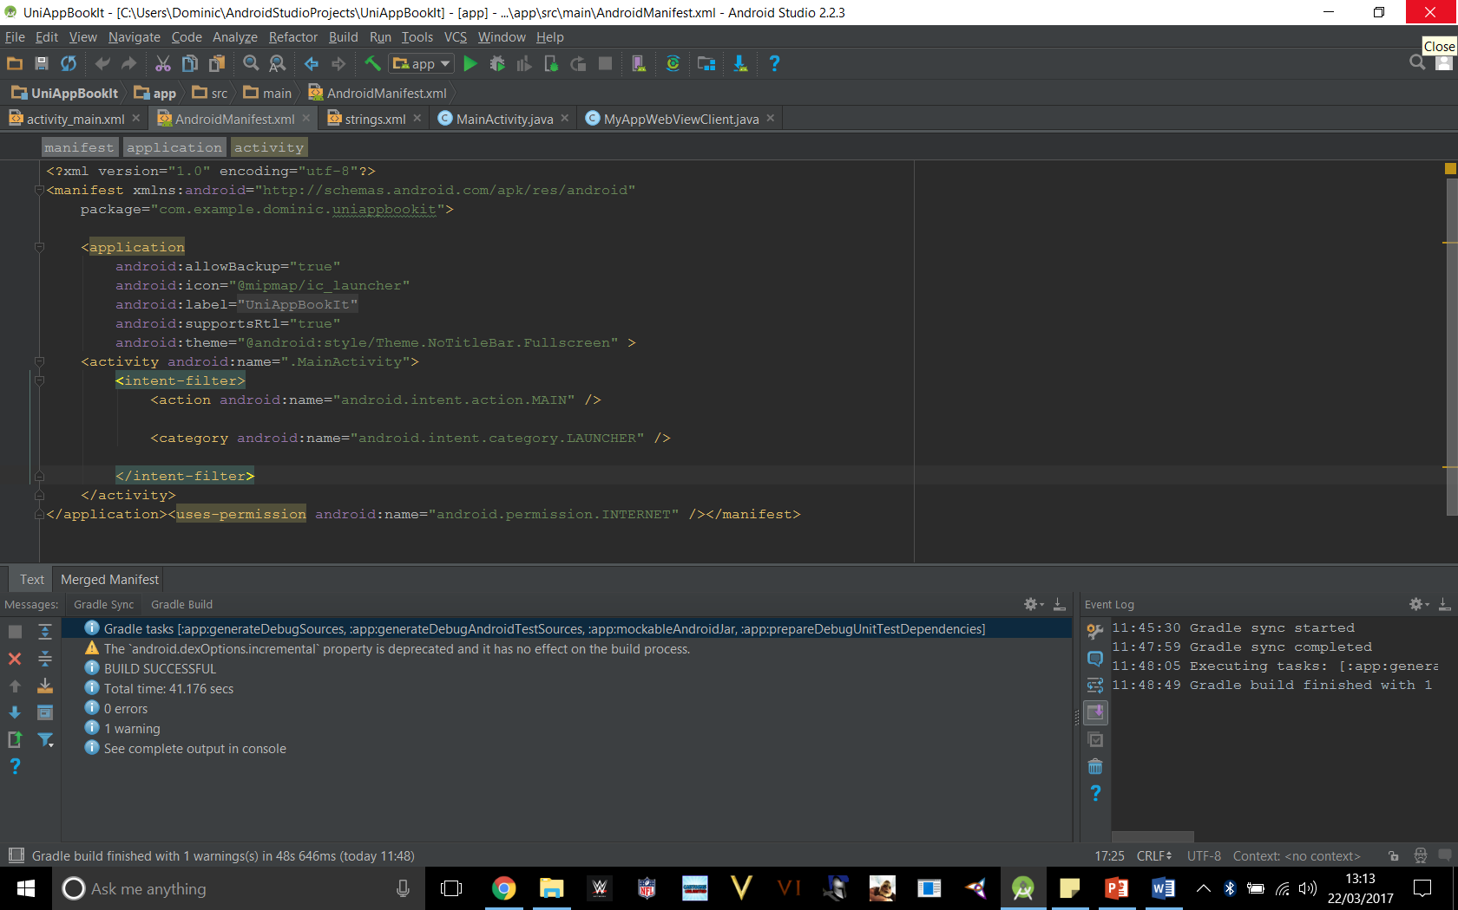

Within my code you can see you have a application section what this does it lets me specify the metadata for my own android application this includes the title of the app which is “UniAppBookIt”, the icon is what you find on the app library on your phone or tablet and then it comes to the theme this is just the layout of the app so I set mine to become fullscreen. So no matter what phone browser you use it will become full screen automatically. Now for the activity what this is that every activity shown by your android app, an activity tag is mandatory. It can be set by using a android:name attribute to specify the class name. It also must include the main launch Activity and any other screen or dialog so that it can be displayed.

Once all of this was done I went a created the icon, splash screen and the APK, the icon all I did was take the Ke (image 4) from the kent logo as that in my opinon gives it a more proffectional look to the app. With the Splash screen I created two one a joke one with a beer drinking sad panda (image 5) and then what a created for the app (image 6) which is a spartan helmet with book it on the arc.

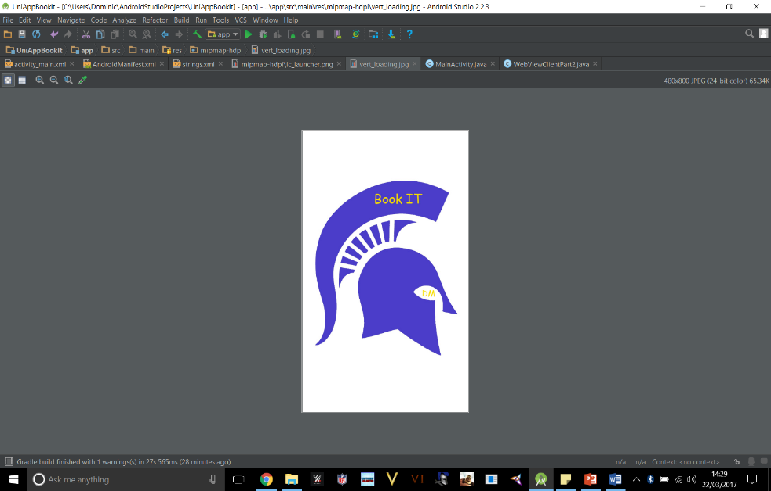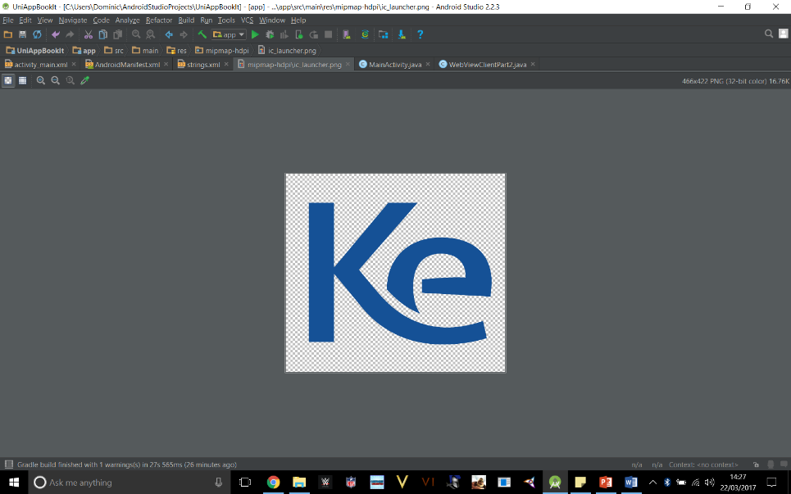

Image 6

Image 5

Image 4